

**Lovely Professional University**

**INT213**

**PROJECT**

***ON***

**TYPING SPEED TEST**

Submitted to**: Sagar Pandey**

Submission**: Nov, 2020**

Group Members**: Subhash Kumar (roll – 51)**

**Supriya Kumari (roll – 46)**

**BTech (CSE)**

**Section – K19HZ**

**Group – 2**

**ACKNOWLEDGEMENT**

Firstly we would like to express our special thanks to our teacher **Mr. Sagar Pandey,** who has given us this opportunity to do this exciting and helpful project in python. Since this is our very first Project, we have given our best and while doing this Project, we came across a lot new things and techniques that helped us to enhance our knowledge for further any Projects.

We are also thankful to our friends who have helped us in making this project throughout and innovative discussions with them.

We are truly making this project for our knowledge enhancement and not just for marks.

Thanks again to all who helped us.

Supriya Kumari Subhash Kumar

BTech CSE BTech CSE

**Summary of the Project**

* Our Project is all about checking the typing speed of the user
* It will calculate the WPM, accuracy and also the total score
* Firstly one window will be open and ask the user to select any level among beginner, intermediate and advanced
* Depending upon the level , a new window will be open
* We have created three different text files containing words according to the levels
* Users have to type the given word in the entry box and hit enter till 1 min
* Timer will be started once the window has started and it will stop when time left becomes 0
* Time left is shown on the top right side and score is calculated on the top left side
* Once a user will hit the right word, score will be increased
* When timeleft becomes 0, user will get a notification to retry or cancel
* When user selects the Cancel option, it will show the output as WPM ,Accuracy, and the total score
* When user selects the Retry option, it will give the output as WPM, Accuracy and the total score and everything will be set to 0
* Once the timeleft will be less than 10, text color will be changed to Red so that user will come to know that less time is left
* Also we can see the inputs typed by user stored in a list and the correct input typed by user as well , the length of total characters typed by user and also the length of correct input on the shell

**PROJECT OBJECTIVES AND RESEARCH**

Firstly we have tried to search for all those Typing speed games GUIs so that we can take idea that what the different widgets we can use in our project. Further we have gone through the different sites and videos, and from there we took different ideas and discussed together to make our project more effective.

After all the discussions, we together made finally the rough design and decided to make our Project using Tkinter library and then we started implementing the same. During the implementation, we came to know about various techniques and used in our project also. Like doing the sliding of the title of the project in a fixed width that makes the project more attractive and like when timeleft becomes less than 10s then changing the font color to red so that user comes to know that less time is left.

The main objective of our Project is to enhance the typing skills of User by letting them know their WPM and accuracy as well. As just speed is not the only criteria, there should be accuracy in typing as well. Also there are different levels in our Project so that depending on the level of the user, they can select and start practicing starting from beginner to Advanced level. This can be useful and helpful for those people who are not good at typing , they can do this test and get to know where they need to improve.

We have also introduced a Score label on the top left corner of the screen so that user will have an approximate idea that whether they are typing with accuracy or not.

**PROJECT DESCRIPTION**

* We have decided to use Tkinter python library for making GUI and Timeit library for the calculation of time.
* Random function is used to fetch the random words from the different text documents for the speed typing test
* For first window,
* 2 Labels and 3 Buttons are used
* Icon and background image has been used
* For second window depending on the button chosen by User,
* 3 functions, 6 Labels and 1 entry box has been created
* User defined functions are created to make the sliding title to calculate the WPM and Accuracy and score
* We have used file handling to open and read the text documents containing words
* We have also used event handling like binding the enter key with function call
* We also used some inbuilt functions like .focus_set() so that there is no need to enable the entry box .User can directly type as soon as they open the window.
* Then we just repeated the same code thrice just the change being the text document for different level and the function name.

**IMPLEMENTATION**

* First of all we imported all the required libraries such as Tkinter and TimeIt and functions like random and messagebox from Tkinter.
* Then we created the window and changed its geometry, icon, and introduced Labels and image.
* Some functions are:
* **LabelSlider() 🡪** It will make the title Label as sliding one or moving
* **GetSentence ()🡪** uses file handling. Open the given file, reads the content and randomly gives one word.
* **Startgame () 🡪** It will count the score and miss depending upon the input by user and clears the entry box when Enter is pressed by the user.
* **Time ()🡪** It will calculate the time for which window is open and also the timeleft from 1 min visible on the top right corner. when the time finishes, it will pop up a messagebox asking for retry or cancel and then showed up the results such as WPM and Accuracy
* Further for next window, above functions and some Labels are created such as:
* **fontLabel**
* **ScoreLabel**
* **WordLabel**
* **scoreLabelCount**
* **timerlabel**
* **timelabelcount**
* **gameplaydetaillabel**
* We have created one entry box to take entry form the user and then binded the Enter key with the function call

***Calculation for WPM and Accuracy***

* The concept behind calculating the score and miss is pretty simple , we have created two variables Score and Miss initialised to 0 .When the input from user is equal to the random word selected (wordEntry.get()==wordLabel['text']),then Score will be incremented otherwise miss.
* Once the time is over, total score is calculated as (Score – Miss) i.e.,
* Total Score = Score – Miss
* Further we have created two separate lists ,one for containing the input from user and one to contain the correct inputs
* Just as above, when (wordEntry.get ()==wordLabel['text']) then we will append the input typed by user in both the list else append in just one list that is containing the all input.
* Then we traversed through the list and count the total characters in both the list .Let say, total length of characters in list containing all input = count

And correct input characters length = correct_input

And total time taken = time

* Since a normal word contains 5 letters , so total words = count/5
* Total words per minute = count*60/5*time
* HENCE, **WPM = COUNT*60/5*TIME**
* **ACCURACY = correct_input*100/count**

**Calculation of time**

* Imported Timeit library for the calculation of time
* We have defined a function also to calculate the timeleft visible on the top right corner
* “Timeleft” has nothing to do with the calculation part. It is just for the user’s convenience
* Timeleft will be start decreasing as soon as the user hits Enter after entering one word , as we have initialised the variable timeleft as 60
* But the actual timer will be started as soon as the user selects one among the levels (Beginner,Intermediate,Advanced)
* The timer will be stopped when the timeleft becomes 0 or the window is closed.
* So we will be able to calculate the total time taken by the user to type the words i.e., t = t1-t0
* The variable timeleft is not the proper time taken by the user as it will start decreasing when the user will type one word and then hit enter, but the time taken by the user to type the first word is not included in that
* But the t is the proper time taken by user including that first word also
* Now since we have calculated the total time, so it becomes easy now to calculate the WPM and Accuracy.

***LabelSlider working***

1. Firstly we have initialised two variables count as 0 and sliderwords as an empty string
2. Then we have initialised text variable to our Project name i.e., “Welcome to Typing Speed Game”
3. Now we have checked the condition that whether count > the length of text
4. If true then reset count to again 0 and sliderwords as empty string
5. If false then add the text[count] into sliderwords
6. Increment the count variable
7. Configure the fontLabel that we have created with new value in sliderwords
8. Further we’ve used one inbuilt function i.e., .after(time, function call)
9. This inbuilt function will call the LabelSlider function after every 100 ms
10. And this process will continue throughout the game

* We have introduced one Label for this and fixed its width so that the topic will move or slide within that fixed width only.

**Modifications**

* We have divided our project in different levels :

1. Beginner level
2. Intermediate level
3. Advanced level

* We have calculated the WPM and Accuracy through the calculation of our own not used any in-built function for that
* We have used Messagebox for asking the user whether they want to Cancel or Retry the game
* Did the sliding of the project topic so that it looks attractive
* We have created three different text files containing words taking in consideration the three different levels that we have introduced.
* Used the timer to calculate the exact timing for which window opens so that user will get the correct output.

**Project Contribution**

* WE both group members have tried to give our best in this project
* WE both have equally contributed in the Project
* All the Discussions and implementation and modifications are done together
* WE have equally shared our ideas and sources or anything related to this project
* Initially we both learnt about different modules and libraries and then decided and planned to finish this project.
* All the work related to this Project either Code Writing or Report Making or Presentation, we both have contributed equally from our side.
* We both are equally responsible for the pros and cons of this Project as we have given the equal efforts

**SCREENSHOTS OF THE WORKING PROJECT**

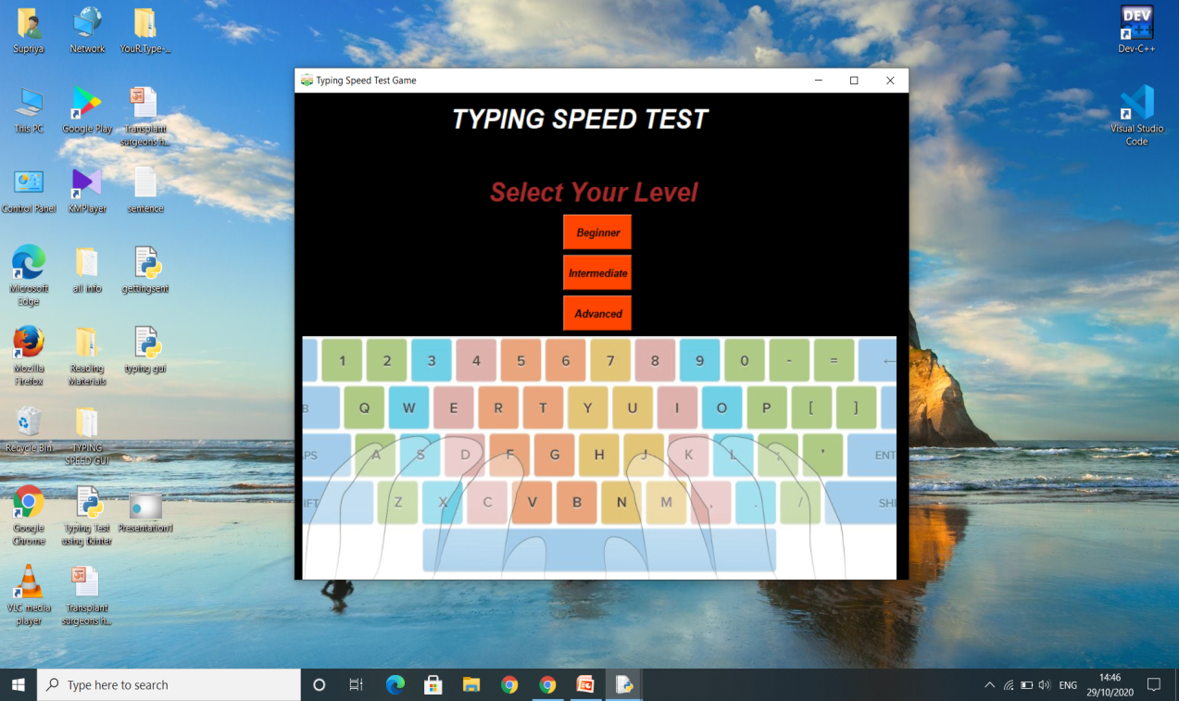

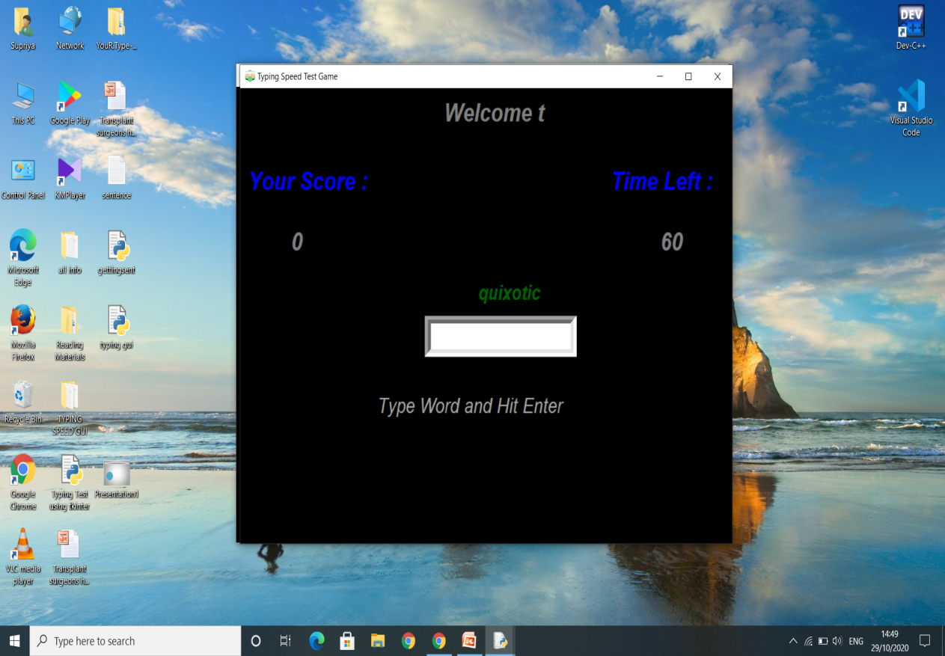

**Conclusions**

Our Project is giving the same output as we have designed in rough and expected in the very beginning. Since we have calculated the WPM and Accuracy from the total length of input characters not just by assuming anything, so it is giving the Correct WPM and Accuracy.

Anyone can rely over this small Python Project and enhance their typing skills by keeping track of their speed and accuracy and by continuous practicing.

This small Project is very simple to implement, exciting and helpful as well.

***REFERENCES***

***https://www.geeksforgeeks.org/how-to-test-typing-speed-using-python/***

***https://www.skyfilabs.com/project-ideas/speed-typing-test-with-python***

***https://techvidvan.com/tutorials/project-in-python-typing-speed-test/***

***https://www.datacamp.com/community/news/python-project-on-typing-speed-test-build-your-first-game-in-python-f28no23fbi***

***https://realpython.com/intermediate-python-project-ideas/***

**THANK YOU**